THE 6TH CONFERENCE ON RESEARCH IN IT PRACTICE, 20-24 OCT 2025, BRISBANE

Brisbane’s Housing Affordability Prediction:
A Data-Driven Study
Samad Zaheer, Faculty of Science, Queensland University of Technology, Brisbane

Abstract
Policymakers, urban planners and local communities have been raising their concerns about the escalating housing affordability crisis in Brisbane. The following study presents a data-driven approach which explores the future demand of housing and imbalances of supply by integrating spatial data of land supply with population projections across regions under Statistical Area Level 2 (SA2). The aim of this research is to identify potential gaps in meeting future population needs and estimate the projected dwelling yield. We conducted a comprehensive data pipeline involving data cleaning, feature engineering, exploratory data analysis and machine learning by using publicly available datasets from the Queensland Government and the Australian Bureau of Statistics.
We developed two predictive models: a Random Forest Regressor which would estimate total dwelling yield and a Random Forest Classifier which would categorise the yield potential into Low, Medium and High groups. The random forest regressor achieved a R² score of 0.49 and mean absolute error of approximately 5,756, while the random forest classifier achieved an accuracy of 83%, with a micro F1-score of 0.74. The findings clearly highlight the spatial disparities in land supply readiness in relation to projected population growth by 2031.
This research has given great insights for the development of urban policy and planning of strategic housing, mainly in identifying zones of high-risk SA2 which had significant housing shortfalls. It also proved how technologies like machine learning and geospatial data integration can help in decision making for sustainable housing development.
Keywords
housing affordability, Brisbane, dwelling yield, machine learning, land supply and population
projections
1. Introduction
Australia is suffering from many urban challenges and housing affordability remains one of the most pressing one particularly in high-growth metropolitan regions like Brisbane. With rapid growth in population and limited urban expansion, the difference between land supply and housing demand has created a lot of pressure on the housing market. In this paper, we are demonstrating a data-driven study that makes use of geospatial land supply data and demographic projections to identify patterns in housing availability and estimate future dwelling yield shortfalls across Brisbane’s Statistical Area Level 2 (SA2) zones. The study aims to identify spatial inequalities between land readiness and future population needs, and it proposes an evidence-based approach to support policy-making and urban planning.
In Australia, housing costs have been rising significantly since the last ten years, often outpacing inflation and income growth of the country (Gan & Hill, 2009; Shi & Phillips, 2023). Like other major cities, Brisbane’s housing demand is mostly driven by population growth, zoning restrictions, infrastructure development, and other economic factors. Although price-to-income ratios and rental stress indicators are frequently used to measure housing affordability, studies recently have suggested that a more localised and spatially informed analysis is necessary to increase understanding of the land supply pipeline and its ability to meet projected demand (Reina & Winter, 2022; Lee et al., 2022). Much of the existing literature and research has focused on price prediction, market forecasting or macroeconomic modelling. However, a significant gap still remains in analysing how future population projections intersect with land availability at a sub-city scale for cities like Brisbane, where much of the planning decisions are made at granular geographic levels.
This paper addresses an important knowledge gap by using parcel-level land supply data enriched with demographic forecasts to evaluate the housing capacity. We examine whether the current land pipeline across Brisbane’s SA2 regions can accommodate population growth projected to 2031 and beyond by merging datasets from the Queensland Government Statistician’s Office (QGSO), Australian Bureau of Statistics (ABS), and Open Data Queensland. Pre-existing studies that integrate machine learning into research of urban housing are likely to focus on price regression (Kou et al., 2021; Zhang & Zheng, 2020) or socioeconomic classification. But our research pivots toward spatial housing sufficiency, hence offering a novel perspective on land readiness, yield estimation, and housing gap identification with the use of predictive analytics. The presented approach is not only critical for city planners and policymakers, but its also important for developers, housing advocates and communities who need clarity on where future development may be lacking.
Estimate the dwelling yield potential of Brisbane’s SA2 regions and identifying areas where the projected population growth may outstrip available housing supply is the primary objective of this research. Our central question is: “To what extent can existing land supply meet projected population demands at the SA2 level in Brisbane by 2031?” To address this question, we have developed a predictive modelling pipeline to: (1) estimate dwelling yield from parcel and timing information, (2) calculate per-capita land supply indicators, and (3) classify zones into categorical tiers of housing readiness. The scope of this study remains limited to SA2 areas within the Brisbane City Local Government Area, ensuring granularity and at the same time allowing for generalizable insights. Our models offer a structural approach to understand the mismatch in spatial supply and demand as they focus on land capacity and don’t just focus on price or affordability stress.
We have adopted the mixed-method data science approach which merges geospatial data processing, exploratory data analysis (EDA), and machine learning. We cleaned publicly available land supply datasets and spatially joined them with SA2 population projection data for the years 2021 to 2046. The feature engineering steps included creation of metrics such as dwelling yield per capita, population density, and estimation of dwelling gaps based on standard occupancy assumptions. We trained two models: a Random Forest Regressor to predict total dwelling yield, and a Random Forest Classifier to categorise zones by the potential yield level. The performance if model was evaluated using metrics like R², MAE, and F1-score, and results were interpreted using feature importance and confusion matrices.
The main contributions of the presented research are its policy-oriented insights and practical relevance. By visualising the gaps between projected capacity and future demand, the study unearths important locations of low supply might exacerbate affordability issues, if left unchecked. Departments in urban planning can use this bottom-up and data-centric approach to make prioritising infrastructure investments, zoning reviews and housing strategy updates easier. Top-down housing affordability relies on macroeconomic indicators but this research focusses on micro-geographic insights and spatial equity in development planning.
The rest of the paper is organised as follows: A review of existing literature in areas like housing affordability, predictive housing modeling and land-use planning is presented in Section 2. The outline of the methodology, including data sources, preprocessing, feature creation and modeling strategy is included in Section 3. The results and implications are discussed in Section 4. The paper is concluded in Section 5 with the summary of findings, limitations highlights and suggested directions for future research work.
2.Related Work (Literature Review)

Introduction
Urban planners, economists, and policymakers, especially in high-growth metropolitan regions like Brisbane have long been concerned with the multidimensional issue of housing affordability. With increasing prices of Australian housing market and uneven supply across various regions, there is a rising need for research that looks past the macroeconomic affordability indicators and explore spatial, demographic, and infrastructure-linked insights at granular geographic levels. Conceptualization of housing affordability, drivers of supply-demand imbalance, geospatial and machine learning approaches in housing research and government responses to land readiness and urban development are the key research themes that relevant to the study and examined in this literature review. Our evaluation yields policy-based and academic contributions to shed light on the current knowledge and draw attention to the gaps our research aims to fill.

2.1 Defining and Measuring Housing Affordability
Affordability in housing is measured traditionally through simple indicators like the rental stress benchmarks or price-to-income ratio, which provide good general insights but often overlook spatial disparities and the range of diversity in households. Gan and Hill (2009) argue that focussing solely on median-income ignores low-income and diverse household arrangements, oversimplifying the housing situation we are addressing. Similarly Reina and Winter (2022) state that traditional metrics hide deep-rooted affordability issues, creating a need for new tools that focus on geopgraphical or spatial inequalities and land-use constraints. Mulliner et al. (2016) pointed out that the academic community around the globe is seeing a surge in housing affordability literature over the past decade, but a lack of agreement on unified metrics that account for ever-changing population shifts and land availability are to be noted.
The mentioned limitations of traditional and conventional affordability measures set the foundation for our study’s emphasis on dwelling yield, parcel-level land readiness, and population growth projections as practical proxies for housing capacity and spatial sufficiency.

2.2 Urban Land Supply, Planning Constraints and Housing Supply Dynamics
In recent study, an important trail connects land supply constraints to escalating housing affordability issues.According to Phibbs and Gurran (2021), the elasticity of housing supply has a significant influence on zoning decisions and planning frameworks, especially in Australian cities. In Brisbane, a bottleneck in housing availability has been created because planning schemes, infrastructure funding and land use approvals have often lagged behind population growth. Lee, Kemp, and Reina (2022) review the role of land-use regulation and contend that supply-side constraints can skew market dynamics even in developed economies if they are not counterbalanced with forward-looking planning.
Wibowo and Santoso (2022), focusing on Jakarta, have illustrates how hotspots of underdevelopment and unmet demand have been revealed across urban zones with the help of spatial modeling of affordability. Even though their study uses multivariate regression, their methodology demonstrated the value of spatial analysis at sub-city levels, a gap which is often underexplored in Australian contexts. Our work draws from these insights by evaluating the supply capacity at the SA2 level, and integrating not just zoning readiness but projected population demand.

2.3 Machine Learning and Predictive Approaches in Housing Research
Due to availability of large-scale demographic and spatial datasets, the integration of machine learning (ML) into housing research has grown significantly lately. To predict housing prices, Kou et al. (2021) evaluated ensemble learning models such as Random Forest and XGBoost and found that ML methods are outperforming traditional econometric models in capturing nonlinear correlations. Zhang and Zheng (2020) demonstrated the value of machine learning (ML) in risk zone classification and trend forecasting by using Random Forest and Gradient Boosting models to regional housing markets.
In the context of Australian policy, since majority of this research is focussing on price prediction, there is a significant dearth of research giving attention to ML applications in housing yield estimation, land readiness categorization or dwelling gap identification. Our research project expands on these methodologies by training Random Forest regressors and classifiers to quantify capacity and classify housing yield zones, instead of predicting price, thus contributing an applied framework for decision-makers in land-use planning and housing policy.

2.4 Demographic Projections and Land Readiness Data Integration
The intersection of population projections with land supply data is still lacking in empirical literature. Although government agencies like the Queensland Government Statistician’s Office (QGSO, 2021) and the ABS (2025) provide comprehensive and rich datasets on land parcels, timing categories and growth forecasts, the academic engagement with these datasets is limited. It was suggested by Shi and Phillips (2023), in their study of housing dynamics in Australia during 2020–23, that structural variables such as development pipeline of land and influx of future population must be connected with realtime indicators.
By combining geographic land parcel data with population projections at the SA2 level, our research seeks to close this data integration gap and produce additional derived or composite metrics like dwelling yield per capita, population density per km² and the dwelling gap (future need vs. available supply). These derived or composite indicators help us gain richer insights into spatial preparedness than insights from raw housing price metrics or land stock alone.

2.5 Government and Infrastructure Policies
Our research has helped in demonstrating the importance of investment made by the government and timing of infrastructure in influencing dwelling supply outcomes. Phibbs and Gurran (2021) stress that though land may have already been zoned for development, practical issues like delays in water, road, and electricity provisioning often stall the delivery of actual housing. This is supported by the Urban Development Institute of Australia (UDIA), which has often cited “serviced land” as a better standard than “zoned land” for measuring supply.
Our use of the “indicative timing” field from the Queensland Government's land supply dataset sheds light on this nuance by categorizing parcels into short-term, medium-term, or long-term readiness, we simulate the actual delivery of housing, rather than theoretical zoning capacity.

Conclusion: Synthesis and Identified Gaps
With research that offer insights into affordability measurement, supply-demand modeling, and the role of government regulation, this literature review has revealed a highly rich and rapidly evolving field. However, there are still a lot of gaps like:
- In Australian urban research, there’s significant underutilisation of micro-level spatial analysis of land readiness and housing supply capacity.
- Pre-existing machine learning applications in housing seem to primarily target only price prediction instead of supply sufficiency or even future population accommodation.
- There are very few studies that integrate public demographic forecasts with land readiness data to be able to estimate shortfalls in future housing or spatial disparities.
- The focus on policy-practical indicators like parcel timing or yield per capita, that can directly inform planning strategies is, very limited.
By filling in these gaps, our study has proposed a new modelling framework that combines spatial datasets, demographic projections and ML-based housing yield classification to offer practical insights for Brisbane’s urban planning ecosystem. It goes beyond theoretical affordability metrics to focus on structural, supply-side enablers which a critical step towards equitable and sustainable housing policy.

3. Methods

3.1 Introduction to Methodology
By developing predictive and classification models that estimate dwelling yield and categorise yield adequacy, the primary objective of this research was to examine the sufficiency of future housing supply across SA2 regions of Brisbane. The research answers the questions mentioned below:
- Can we use population projections, when combined with parcel-level land supply data, to estimate future housing sufficiency?
- What machine learning techniques can effectively predict dwelling yield and identify at-risk regions for housing shortfall?
- How can derived or composite indicators like the dwelling gap and yield per capita provide any spatial insights which would be relevant to policy?
To be able to answer these questions, we adopted a research design which was data-oriented and predictive, and it involved the integration of demographic projections, spatial datasets and geospatial land supply data. The approach that we used here was targeted to concentrate on machine learning, data preprocessing and feature engineering. It was selected due its strength in scalability and robustness in generating understandable and actionable insights. The research also involved developing composite or derived metrics like the dwelling gap and dwelling yield per capita so that it can complement model outputs and offer deeper and richer context for regional planning decisions.

3.2 Research Design and Development
The study follows a structured form which consists of phases mentioned below:
- Data Collection: We have sourced data that is available to public from open government sources like the Queensland Land Supply and Development Monitoring (LSDM) portal, the Australian Bureau of Statistics (ABS) and the Queensland Government Statistician’s Office (QGSO). These platforms included:
  - Parcel-level land supply data in CSV format for Brisbane.
  - SA2 shapefiles and attribute tables for spatial joining (GeoPackage format).
  - SA2 level population forecasts from 2021 to 2046 (Excel, cleaned to CSV).
  - Household income, mortgage, rent and dwelling density and alike demographic indicators (G02_QLD_GDA2020.gpkg).
- Data Preprocessing:
  - To deal with inconsistent encodings, duplicated records and missing values we have used Pandas library.
  - We used GeoPandas to perform spatial joins by mapping land parcels to the corresponding boundaries of SA2.
  - Columns were renamed, filtered and standardised for merging across datasets with different schemas.
- Feature Engineering:
  - We used population projections to calculate Dwelling Yield per Capita for 2026 and 2031.
  - Dwelling Gap was calculated which is the difference between available yield and estimated dwelling needs (we have assumed 1 dwelling per 2.5 people).
  - For classification we divided Yield Category into three labels (“Low”, “Medium”, “High”).
- Model Training and Evaluation:
  - We used a Random Forest Regressor to forecast total dwelling yield on the basis of simplified feature sets.
  - A Random Forest Classifier was developed to categorize regions by dwelling yield levels for policy interpretation.

3.3 Data Collection Methods
We used secondary data from reputable government and statistical sources in this study so that we can minimise the need for primary collection of data.
- The LSDM portal provided us parcel-level land supply data and it also included fields like Dwelling_Yield, Parcel_Count and Indicative Timing.
- Population projection data (QGSO, 2021) includes all the predicted population values for 2021 - 2046 across all SA2 zones present in Queensland.
- Geospatial administrative boundaries, which was sourced from ABS (2021 edition), helped to facilitate SA2-level aggregation.
- G02_QLD_GDA2020.gpkg helped us with socioeconomic indicators like median household income, mortgage payments and average rent.

3.4 Data Analysis Techniques and Tools
We executed the described workflow in a Jupyter Notebook by using Python programming language and the following libraries:
- pandas and numpy (data manipulation).
- geopandas and shapely (spatial joins and visualizations).
- scikit-learn (model training and evaluation).
- matplotlib and seaborn (visualizations).
- xlsx and CSV readers (load and merge files).
We performed Exploratory Data Analysis (EDA) in order to get understanding of the distribution of dwelling yields, parcel counts and timing categories. We also identified a correlation heatmap which was helpful in identifying relationships between variables and guiding feature selection.
We used the following modeling approaches:

1. Regression Model
- Target: Total_Dwelling_Yield
- Features: Parcel_Count , Avg_Dwelling_Yield, 2031 Population
- Evaluation metrics: MAE, MSE, R² Score
- Outcomes: R² = 0.49, MAE ≈ 5,700 homes (approx.)

2. Classification Model
- Target: Yield_Category (Low, Medium, High)
- Features: Avg_Dwelling_Yield, 2031 Population, Parcel_Count
- Evaluation metrics: Accuracy, Precision, Recall and F1-Score
- Outcomes: Accuracy = 83%, Micro F1 Score = 0.74
By classifying results into actionable categories like “low-yield” SA2s requiring intervention, the approach proved to be easier to understand and communicate for policy communication.

3.5 Validation and Limitations of the Methodology
We has adopted several best practices to ensure reliability like:
- The famous train-test split (80/20), which is applied to take care of overfitting.
- Cross-verification was performed using metrics spanning across both regression and classification tasks.
- In order to avoid leakage of information, label encoding and binning was implemented carefully.
- Model bias or variance risk was minimised by using Random Forest, which is prominent for handling small-to-medium sized data existing in tabular format.

Limitations
Apart from all these advantages, the methodology still has some limitations:
- Generalizability may be affected as the model was trained on a relatively small dataset (n ≈ 88 SA2 regions).
- Temporal dynamics (e.g., market shocks or government incentives) were not included in the model.
- The LSDM dataset contains Indicative Timing field, which is although informative but subjective to planning assumptions.
- We used a simplification that is not accounting for evolving household structures or types of tenure here for the estimation of dwelling need, which is 2.5 people per dwelling fixed ratio.
- This version of the model cannot predict price or affordability but it can approximate structural capacity, which should be interpreted alongside other economic factors.

Summary
This methodology has integrated data from spatial planning with population predictions and ML techniques to generate quantitative as well as categorical insights on supply of future dwelling. The research has brought a framework that is replicable and can be expanded to other urban regions by combining geospatial processing, feature engineering and robust ML pipelines and can be enriched with additional temporal or economic variables in future work.
4. Results and Discussion

4.1 Results

4.1.1 Research Objective Recap
The aim of this study was to assess Brisbane’s capacity to meet future housing needs through the lens of land supply, projected population growth and machine learning models. We sought to answer the following research questions:
- Can spatially referenced land supply data and population forecasts be integrated to model future dwelling yields?
- Can predictive and classification models identify areas likely to experience housing shortfalls?
- What derived indicators can support planners and policymakers in understanding supply-demand imbalances?

4.1.2 Data Collection and Preparation
We created a working dataset covering 88 SA2 regions in Brisbane after cleaning and integrating multiple datasets, such as the LSDM land parcel data, QGSO population projections and ABS SA2 boundaries. This dataset included population forecasts from 2021–2046, parcel counts, average indicative timing of development, and total estimated dwelling yields.
Key descriptive statistics include:
Feature | Mean | Min | Max
Parcel Count | 497.3 | 12 | 6174
Avg Dwelling Yield | 7.34 | 1.2 | 28.5
Total Dwelling Yield | 4730.1 | 50 | 45200
Projected Pop. (2031) | 11321.6 | 1617 | 27900

These figures demonstrate large variability across SA2s in terms of parcel availability and dwelling capacity.

4.1.3 Exploratory Data Analysis and Feature Engineering
Initial EDA revealed the following:
- A positive correlation between parcel count and total dwelling yield (r ≈ 0.81).
- Indicative timing categories were bent towards long-term development.
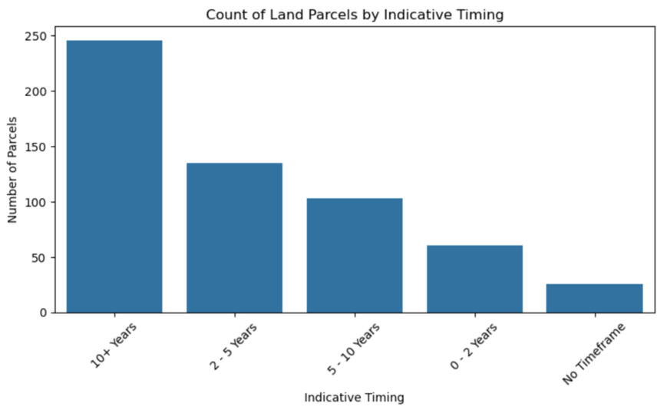

- We found a contrast between the supply capacity and the predicted demand which was highlighted by the dwelling yield per capita (2031) values, which varies from below 0.1 to over 3.5.
We had also created the dwelling gap indicator, which is defined as the difference between predicted dwelling need (assuming one home for every 2.5 persons) and available supply.
For example, consider the case Manly West SA2 which had the projection of 8131 people population growth from 2021 to 2031, which translates into need for 3252 dwellings, but it had only 1166 dwellings planned, indicating a negative gap of over 2000 dwellings.

4.1.4 Regression Model: Predicting Dwelling Yield
Random Forest Regressor was trained using the following features:
- Parcel Count
- Population Projection (2031)
- Average Dwelling Yield
Model performance (test set):
- Mean Squared Error (MSE): 153.2 million
- Mean Absolute Error (MAE): 5756.44
- R² Score: 0.49
Figure 1: Feature importance plot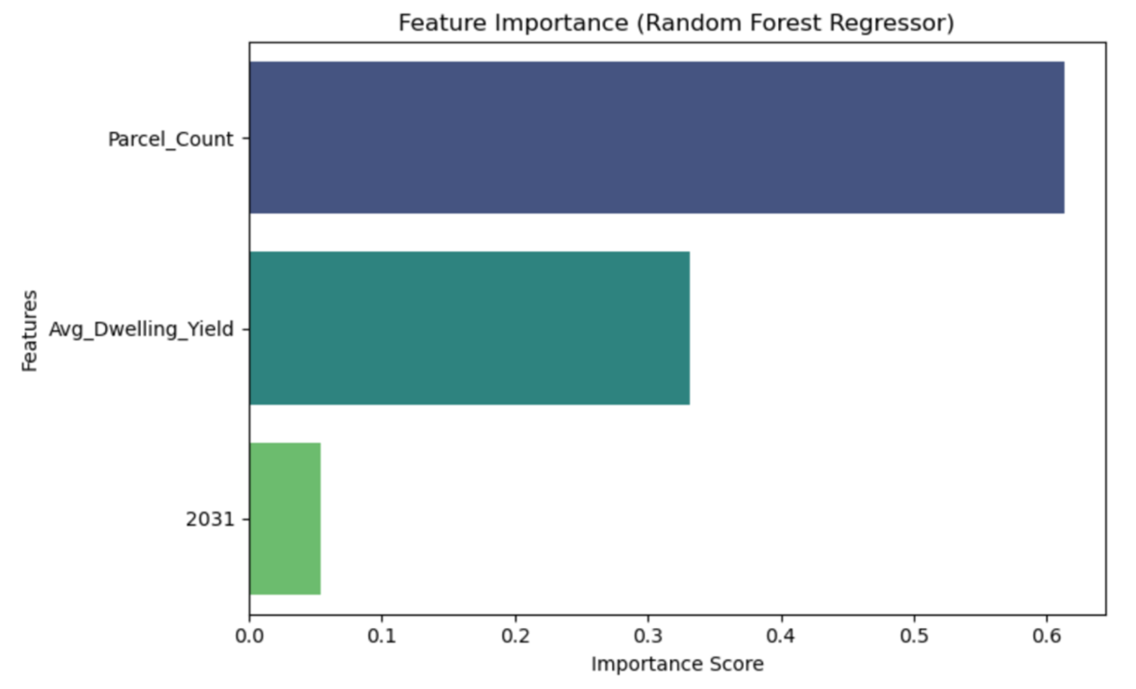

The model revealed that Parcel Count was the feature with highest influence, followed by Avg Dwelling Yield. While the R² score seems to suggest moderate performance, it also demonstrates the model's ability to explain close to half the variance in dwelling yields, which is understandable, given that the dataset size was small and urban development dynamics is quite complex.

4.1.5 Classification Model: Categorising Dwelling Yield
We also trained a Random Forest Classifier to label regions into three categories based on yield:
- Low (<3,000 dwellings)
- Medium (3,000–10,000)
- High (>10,000)

Classification Results:
Metric | Score
Accuracy | 83%
Micro F1 Score | 0.74
Precision (High) | 0.80
Recall (Medium) | 0.33

Figure 2: Confusion matrix of classification results
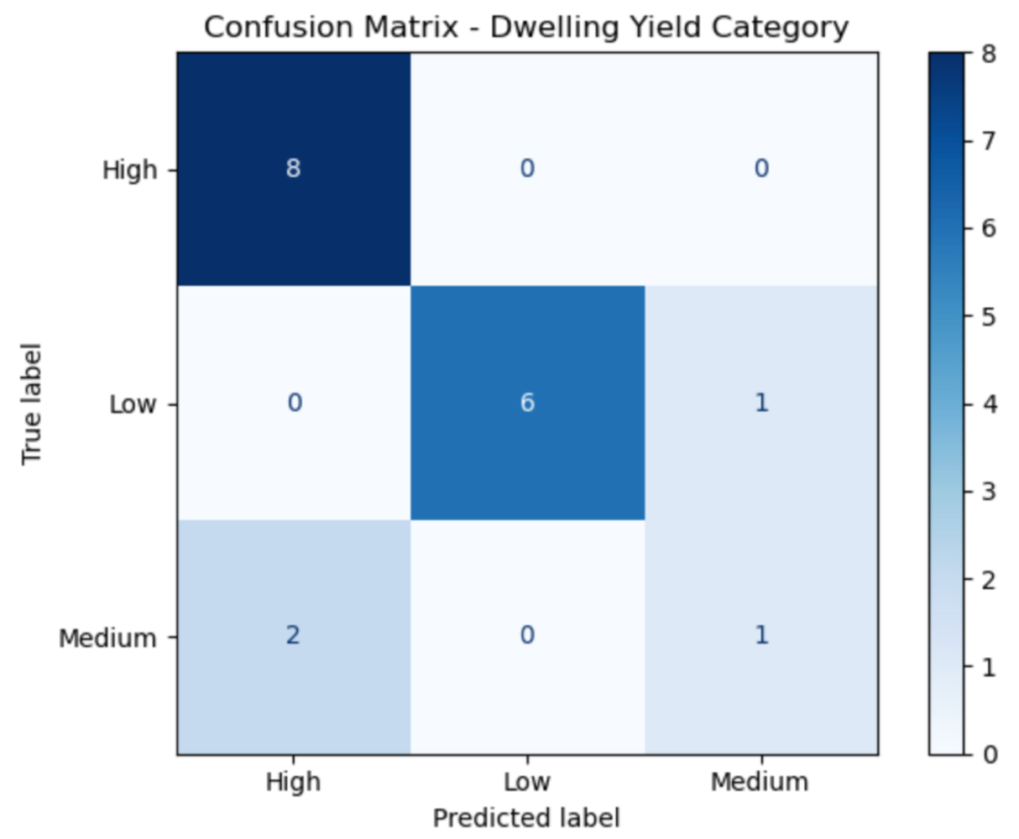
The model showed high performance in identifying High and Low regions, which are most critical from a policy standpoint. Medium regions had lower precision/recall, likely due to fewer samples and boundary overlap.

4.2 Discussion

4.2.1 Summary of Key Findings
- We had successfully integrated land supply with demographic projections in order to create a geospatial dataset for Brisbane SA2s.
- The regression model was able to predict total dwelling yield with modest accuracy using just three features.
- The classification model effectively identified SA2s likely to experience housing stress or surplus based on yield categories.
- Dwelling gap indicator added policy relevance by measuring the excess or shortage of houses expected by 2031.

4.2.2 Meaning and Interpretation
The findings indicate that in many Brisbane neighbourhoods, especially in the eastern and southern corridors the land supply alone is not able to keep up with the population growth. SA2s like Murarrie, Manly and Tingalpa were highlighted as zones with high-risk for low supply by dwelling gap metric. These observations are consistent with concerns expressed in the literature about urban development and poor infrastructure planning (Phibbs & Gurran, 2021).
Even though average yield and parcel count are reliable indicators, population growth is an equally important factor that is to be taken into consideration while planning.

4.2.3 Comparison with Previous Work
Our observations help in supporting the findings from Kou et al. (2021) and Zhang & Zheng (2020), who showed that ensemble machine learning models can accurately capture housing trends with minimal variables. However, unlike prior studies that primarily model price (Wang et al., 2020; Shi & Phillips, 2023), our study focuses on dwelling capacity, a dimension often neglected in affordability studies.
A research gap highlighted by Reina & Winter (2022) and Gan & Hill (2009) was also addressed by us: the disconnect between supply-side planning metrics and population-driven demand forecasting.

4.2.4 Implications
Many stakeholders can benefit from the research:
- The housing gap map can be used by Urban Planners to prioritise infrastructure investments.
- In high-deficit regions, Local Councils may of modify zoning regulations or accelerate planning approvals.
- The classification findings of housing support and growth area strategies can be applied by Policy Makers.
- Since the methodology is replicable, Researchers can be extend it to other Australian cities or even scale it nationally.
Because of its easy interpretability, the classification approach makes it more suitable and understandable for stakeholders who are not technical.

4.2.5 Limitations
- The ability to generalise and the model training depth is affected by the limited size of dataset (88 SA2s).
- With changing household dynamics, assumptions like 1 dwelling per 2.5 persons may not be applicable.
- We hadn’t accounted for Temporal policy interventions (e.g., housing grants, construction delays).
- The model does not incorporate conventional economic affordability metrics (e.g., price-to-income ratio), which would have enriched affordability predictions.

4.2.6 Future Work Suggestions
- Expand the dataset to include SEQ regional SA2s and introduce temporal variables (e.g., past approval trends).
- In order to directly model affordability and not limit it to supply, we can include economic data like median rent, income and mortgage stress.
- Use time-series forecasting models such as LSTM and ARIMA for dynamic population or yield prediction.
- Explore dashboards having geospatial visualisation to make realtime decisions on policy.

5. Conclusions
By developing a predictive, data-driven framework which is integrated with population projections, land supply statistics and housing yield estimates, this study aimed to investigate housing affordability in Brisbane. Identifying future mismatches between dwelling supply and projected population needs and thus enabling better planning decisions and targeted interventions by policymakers was the main objective we focused on.
Through our findings we are able to see that due to population growth that will exceed planned dwelling yields, many SA2 regions in Brisbane might experience significant housing shortfalls by 2031. By employing both regression and classification models, we demonstrated that while precise prediction of dwelling yield remains complex due to numerous influencing factors, categorizing yield potential into classes like "Low", "Medium", and "High" can offer useful insights with over 80% accuracy. These findings have been supported by visualisations and statistical interpretations, which have also provided a spatial understanding of affordability dynamics across the city.
There are multifold ramifications of these results. Firstly, they assist policymakers and urban planner by showing them a more accurate picture of future supply-demand gaps, and help them prioritise infrastructure investments and zoning adjustments in high-risk areas. Secondly, the methodology used here can also be extended to other urban regions which use open datasets, which makes it a scalable and repeatable approach. Thirdly, this work stresses on the potential of integrating government’s open data with machine learning to lead urban sustainability and livability efforts.
However, this study has its own limitations. Our affordability estimation relied on housing supply proxies rather than direct affordability indices due to the absence of finer financial data points like individual income levels, mortgage stress metrics. The limited availability of real-time housing transaction data also affected the precision of regression modelling. Furthermore even though the classification has shown good results, it is suggested to validate the model’s generalizability using external dataset .
In order to have a more comprehensive housing affordability index, future research could incorporate rent-to-income ratios, income distribution, mortgage stress levels and real estate trends. To capture non-linear relationships across larger geographical ranges, deep learning or ensemble techniques could also be explored. To further refine regional categorisations, the feedback from planners and residents can be implemented.
To sum up this research offers a meaningful, practical framework for predicting housing pressures in growing urban cities. The results of the study promote affordability and resilience in housing market of Brisbane by encouraging evidence-based planning and policy initiatives.
Acknowledgements
I would want to thank my tutor, Dr. Hang Jin, from the bottom of my heart for all the help, advice and support they gave me during this project.
Special thanks to the Queensland Government Statistician’s Office and the Australian Bureau of Statistics for providing high-quality population, land supply and housing datasets which served as the foundation of this research.
Lastly, I am grateful to all my colleagues in the research cluster for their insightful discussions during the course of the project.
Author’s biography
Samad Zaheer is a postgraduate student at Queensland University of Technology (QUT) pursuing a Master of Information Technology with a major in Data Science. Data analytics, machine learning and urban research are the areas of his academic interest. Samad is enthusiastic about applying data-driven approaches in solving challenges of real-world, society and policy-related problems.

References
Gan, Q., & Hill, R. J. (2009). Measuring housing affordability: Looking beyond the median income. Journal of Housing Economics, 18(2), 115–125. https://doi.org/10.1016/j.jhe.2009.04.003
Lee, Y., Kemp, P. A., & Reina, V. J. (2022). Drivers of housing (un)affordability in the advanced economies: A review and new evidence. Housing Studies, 37(10), 1739–1752. https://doi.org/10.1080/02673037.2022.2123623
Shi, S., & Phillips, P. C. B. (2023). Housing fever in Australia 2020–23: Insights from an econometric thermometer. Australian Economic Review, 56(2), 203–222. https://doi.org/10.1111/1467-8462.12514
Salma, Y., Sakti,T. (2024). A Spatial mapping for Profitability Consideration of Rental Houses in South Jakarta. Research Gate. https://www.researchgate.net/publication/385809030_A_Spatial_Mapping_for_Profitability_Consideration_of_Rental_Houses_in_South_Jakarta
Subhramanyam, K., Reddy, B. R., Y., Boyapati, S. V. & Karthik, M. S. (2023). An Analysis of House Price Prediction using ensemble learning algorithms. Research Gate. https://www.researchgate.net/publication/371132853_An_Analysis_of_House_Price_Prediction_Using_Ensemble_Learning_Algorithms
Fang, L. (2023). Machine learning models for house price prediction. Research Gate. https://www.researchgate.net/publication/372200602_Machine_learning_models_for_house_price_prediction
Gunawan, A. A. S., & Ohyver, M. (2024, November). House Price Modeling in DKI Jakarta: A Web-Based Comparative Study of Spatial Models. In 2024 IEEE International Conference on Aerospace Electronics and Remote Sensing Technology (ICARES) (pp. 1-7). IEEE. https://ieeexplore.ieee.org/abstract/document/10768046
Ben-Shahar, D., Gabriel, S., & Oliner, S. D. (2020). New research on housing affordability. Regional Science and Urban Economics, 80, 103438. https://www.sciencedirect.com/science/article/pii/S0166046219300791
Begum, H., & Rahaman, M. M. (2023). Approaches of measuring housing affordability: Retrofitting affordability approach from replicability to reality. Jahangirnagar University Planning Review, 21.
Phibbs, P., & Gurran, N. (2021). The role and significance of planning in the determination of house prices in Australia: Recent policy debates. Environment and Planning A: Economy and Space, 53(3), 457-479. https://journals.sagepub.com/doi/full/10.1177/0308518X21988942
Wang, S., Liu, Y., Feng, Y., & Lei, Z. (2022). Spatially-explicit prediction of low-density peri-urban development: comparison between urban and rural scenarios in the Moreton Bay Region in South East Queensland, Australia. https://journals.sagepub.com/doi/full/10.1177/23998083211069382
Australian Bureau of Statistics. (2025). Total value of dwellings, March quarter 2025. https://www.abs.gov.au/
Queensland Government Statistician’s Office. (2021). Population projections: Regions. https://www.qgso.qld.gov.au/
Choi, J., & Varian, H. (2012). Predicting the present with Google Trends. Economic Record, 88, 2–9.
Glaeser, E. L., & Gyourko, J. (2003). The impact of building restrictions on housing affordability. Federal Reserve Bank of New York Economic Policy Review, 9(2), 21–39.
Quigley, J. M., & Raphael, S. (2004). Is housing unaffordable? Why isn't it more affordable? Journal of Economic Perspectives, 18(1), 191–214.
Hwang, M., & Quigley, J. M. (2006). Economic fundamentals in local housing markets: Evidence from U.S. metropolitan regions. Journal of Regional Science, 46(3), 425–453.
Gabriel, S. A., & Rosenthal, S. S. (2005). Homeownership in the 1990s: Aggregate trends and racial gaps. Journal of Urban Economics, 57(1), 101–127.
Debrezion, G., Pels, E., & Rietveld, P. (2007). The impact of railway stations on residential and commercial property value: A meta-analysis. Journal of Real Estate Finance and Economics, 35, 161–180.
Friedman, J. H. (2001). Greedy function approximation: A gradient boosting machine. Annals of Statistics, 29(5), 1189–1232.
Breiman, L. (2001). Random forests. Machine Learning, 45(1), 5–32.

